**Password Protection with PUSH Buttons**

**Using Arduino UNO**

**Description:**

This Project is to design a system using **Arduino UNO** containing **push button** as keys from **0-9 Numbers** which are inputs for Arduino when user enters **Correct password** using push buttons then **Green LED** need to **ON** and **Welcome** message will be displayed in **LCD display**. If user enters **wrong password** then he can attempt another time. If the number of attempts **exceeds** more than **3 times** then **buzzer** need to blow and **warning message** will be displayed in **LCD display** and **Red LED** need to **ON**.

**Block Diagram:**

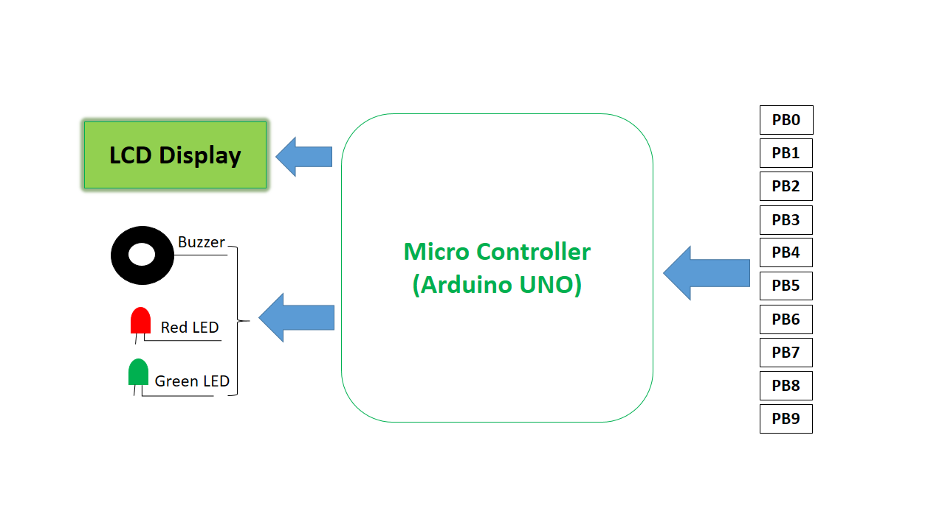

**Inputs and Outputs:**

|  |  |  |  |  |  |  |
| --- | --- | --- | --- | --- | --- | --- |
| **S.No** | **Description** | **Name** | **Type** | **Data Direction** | **Spec** | **Remarks** |
| 1 | Push Button | PB0 | INP | DI | 5VDC | Active High |
| 2 | Push Button | PB1 | INP | DI | 5VDC | Active High |
| 3 | Push Button | PB2 | INP | DI | 5VDC | Active High |
| 4 | Push Button | PB3 | INP | DI | 5VDC | Active High |
| 5 | Push Button | PB4 | INP | DI | 5VDC | Active High |
| 6 | Push Button | PB5 | INP | DI | 5VDC | Active High |
| 7 | Push Button | PB6 | INP | DI | 5VDC | Active High |
| 8 | Push Button | PB7 | INP | DI | 5VDC | Active High |
| 9 | Push Button | PB8 | INP | DI | 5VDC | Active High |
| 10 | Push Button | PB9 | INP | DI | 5VDC | Active High |
| 11 | LCD Display | LCD | OUT | DO | 5VDC | Active High |
| 12 | Red LED | LED1 | OUT | DO | 5VDC | Active High |
| 13 | Green LED | LED2 | OUT | DO | 5VDC | Active High |
| 14 | Buzzer | BUZ | OUT | DO | 5VDC | Active High |

**Flow Chart:**

